BIOC 455
Lecture # 35– Article Discussion
Lecturer: Dr. Leyton – Wednesday, April 11th, 2007

NOTE: This NTC is meant to be used as a study aid to supplement your own class notes. Hence, not all of the text or diagrams contained in the lecture slides will be reproduced here.

Please send any comments or questions about NTCs to either Wanda or James through e-mail at u3.represent@gmail.com .

Last Lecture: So the first 25 minutes of class or so were spent splitting up into 5 groups to discuss different figures or graphs in article Higher Expression of Serotonin 5-HT_{2A} Receptors in the Postmortem Brains of Teenage Suicide Victims by Pandey et al which can be downloaded from WebCT in the Leyton/Young section.

The first group discussed table 1 (Demographic and Clinical Characteristics of 15 teenage Suicide Victims and 15 Psychiatrically Normal Teenagers Who Died of Other Causes). The table shows age, gender, postmortem interval (PMI–which is the number of hours after death they were able to take the brain and put it on ice). There was no major difference in these values between the suicide victims and the psychiatrically normal group, which mostly died from gunshot wounds. What was very notable in the table was how young all the victims were. The psychological diagnoses were made by psychological autopsies, in which in you interview the relatives of the deceased. Some of the suicide victims had no psychiatric disorder diagnosed. The prof said not every suicide victim necessarily has to have a psychiatric disorder. A personality disorder, one of the psychiatric diagnoses on the table, was described as extremes of personalities (extremely introverted, extroverted, or anxious for example).

The second group discussed figure 1:
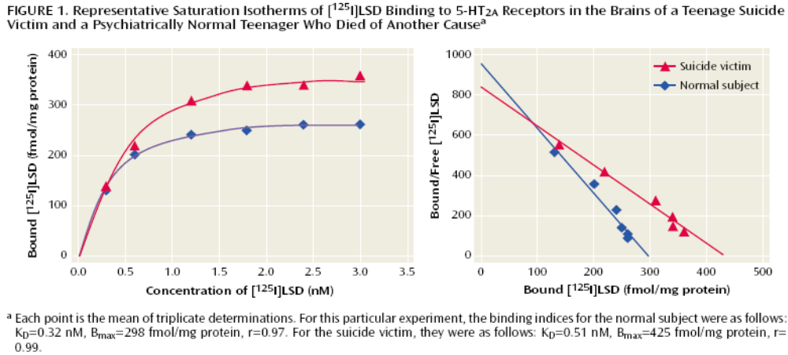
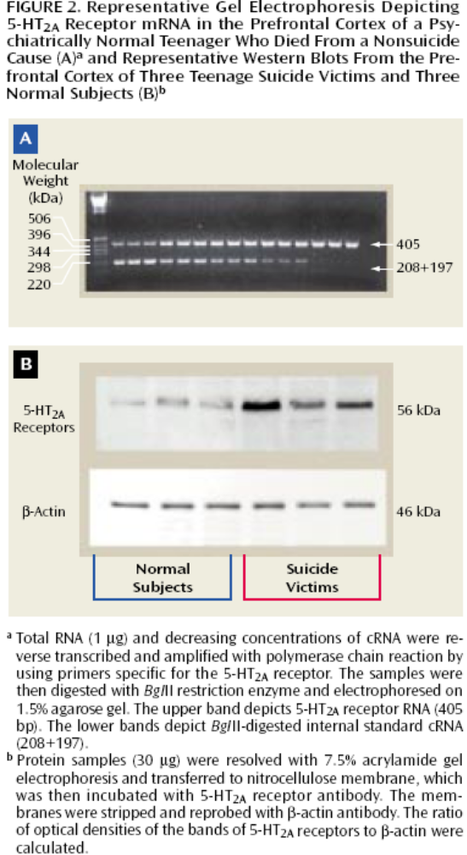
The left graph is a binding assay. Km shifted very slightly so there isn’t a big change in binding affinity between suicide victims and normal teenagers.
For the right graph: In suicide victims there was more binding. On the left they explain in what sense there was more binding. The fact their Vmax shifted up means that there were more receptors sites for the ligand to bind in the suicide victims.
Someone in the class brought up how LSD might not be the best ligand for the h-HT_{2A} receptor to use since it has a secondary binding site/specificity that could affect results and that other better ligands are available that are more specific for the receptor. The prof said it’s not the optimal ligand but based on the regions they were looking at in this study though and other features of the study show that LSD works fine as a ligand for 5-HT_{2A} for this study.

The third group discussed figure 2:
Part A shows the concentration of RNA amplified by competitive PCR with primers specific to the 5-HT_{2A} receptor. The PCR products were then digested with a restriction enzyme and electrophoresed on the gel. The upper band shows the 5-HT_{2A} receptors RNA and the lower band shows the cRNA that was reverse transcribed and cut with the restriction enzyme.
2b is a western blot that shows normal subjects on the right site have lower levels of proteins than the suicide victims. In suicide victims the protein levels are significantly higher in the prefrontal cortex.

The fourth group discussed figures 3 and 4. Figure 3: Low Magnification Photomicrographs of 20 micrometer brain sections showing the six cortical layers of the prefrontal cortex. Immunogold-labeled for serotonin 5-HT_{2A} receptors, and high magnification photomicrographs of pyramidal cell in brain layer V from teenage suicide victim and a psychiatrically normal teenager who died of another cause. In this immunogold assay they show different levels of expression in certain areas of the brain. They found that there was a much bigger increase in the layer V pyramidal cells than most other regions in suicide victims.
Figure 4 was supposed to summarize this but the graph is mislabeled. The blue and red should be switched, showing that layer V pyramidal cells had a higher number of gold particles in suicide victims, not normal subjects. The prof remarked that it’s amazing how often this actually happens, and that he didn’t catch the mistake when he went through the paper.

The fifth group discussed figure 5 and 6. Figure 5 Effects of mental disorders on 5-HT_{2A} Receptor Measures in the Prefrontal Cortex of Teenage Suicide Victims and Figure 6 Effects of Mental Disorders on mRNA and Protein levels of 5-HT_{2A} Receptors in the Hippocampus of Teenage Suicide Victims are statistical analysis’s that shows there were no significant differences between suicide victims with mental disorders and those with no mental disorders in the immunolabeling of the 5-HT_{2A} receptors and the B_{max} of the receptors, but that there was a significant difference in the amount of receptor mRNA levels.

The last 10 minutes of class were spent on a course evaluation.

